Q1- Create an index of name employee_idx on EMPLOYEES with column Last_Name, Department_id

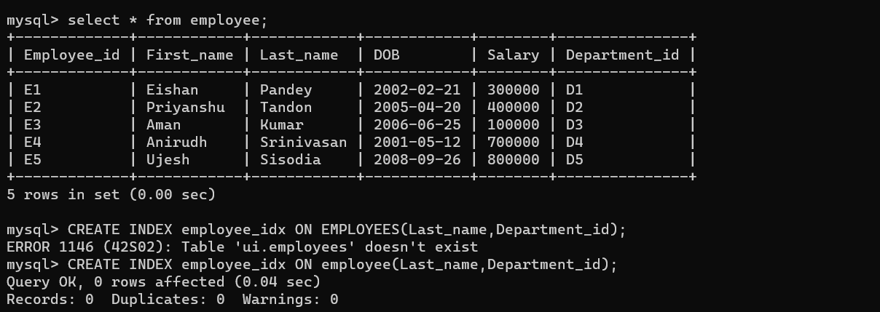

Q2- Find the ROWID for the above table and create a unique index on employee_id column of the EMPLOYEES.



Q3- Create a reverse index on employee_id column of the EMPLOYEES.



Q4- Create a unique and composite index on employee_id and check whether there is duplicity of tuples or not.

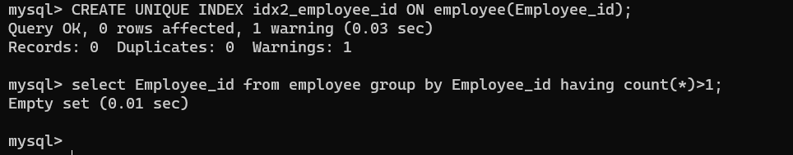

Q5- Create Function-based indexes defined on the SQL functions UPPER(column_name) or LOWER(column_name) to facilitate case-insensitive searches(on column Last_Name).

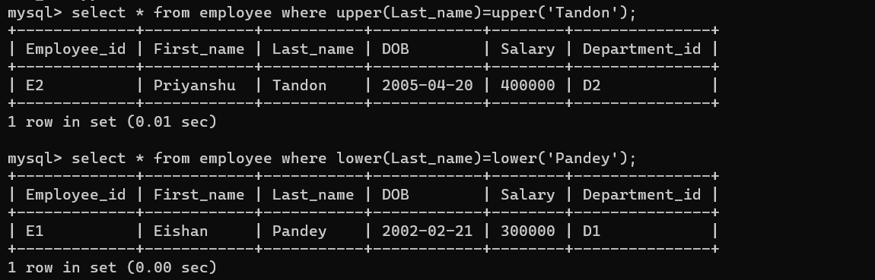

Q6- Drop the function based index on column Last_Name.

